Project Design Phase-II
Data Flow Diagram & User Stories

Date | 05 July 2026
Team ID | Solo Project – Individual Capstone
Project Name | Library Management System (ServiceNow)
Maximum Marks | 4 Marks

Data Flow Diagram:
A Data Flow Diagram (DFD) is a visual representation of the information flows within the Library Management System. It shows how a borrow request enters the system, how it is processed and approved, and how the Book and Borrow Request records are updated as a result.
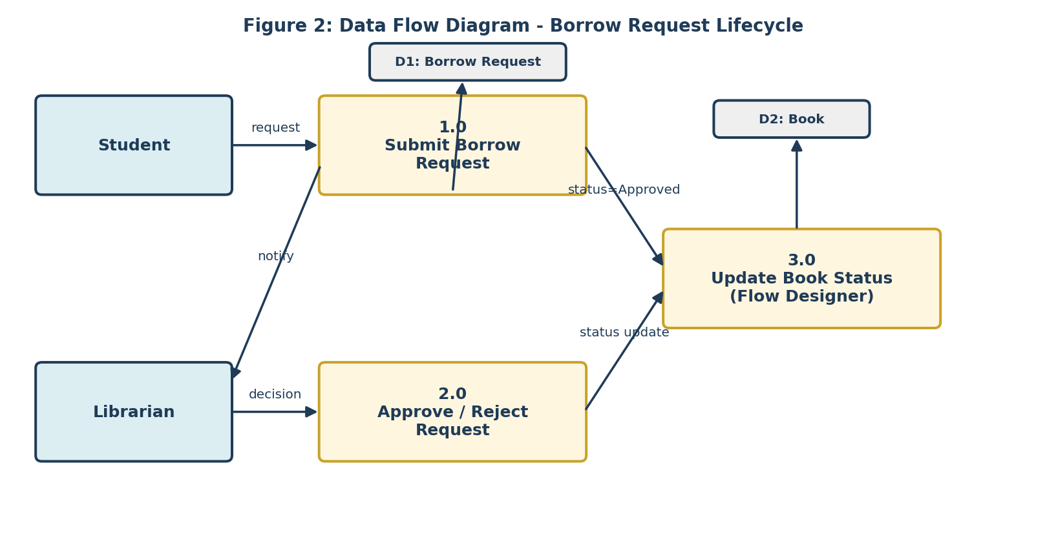

User Stories:
The table below lists the user stories captured for the Library Management System, grouped by user type and functional requirement (epic).
User Type | Functional Requirement (Epic) | User Story Number | User Story / Task | Acceptance Criteria | Priority | Release
Student | Borrow Request Management | USN-1 | As a student, I can submit a borrow request for an available book. | Request is created with Status = Requested. | High | Sprint-1
 |  | USN-2 | As a student, I can view the status of my own borrow requests. | ACL restricts view to my own records; status shows Requested/Approved/Rejected/Returned. | High | Sprint-1
 |  | USN-3 | As a student, I cannot request a book that is already issued. | Reference Qualifier hides books where Status ≠ Available. | High | Sprint-1
 | Notifications | USN-4 | As a student, I receive an email once my request is approved. | Email received naming the approved book. | Medium | Sprint-2
Librarian | Book Management | USN-5 | As a librarian, I can add and update book details (Title, Author, ISBN, Status). | New/updated book appears correctly in the catalog. | High | Sprint-1
 | Approval Workflow | USN-6 | As a librarian, I can approve or reject a submitted borrow request. | Status updates to Approved or Rejected accordingly. | High | Sprint-1
 |  | USN-7 | As a librarian, approving a request automatically issues the book. | Book.Status changes to Issued via Flow Designer. | High | Sprint-1
 | Access Control | USN-8 | As a librarian, I have full read/write/delete access to Book and Borrow Request tables. | ACL grants librarian role full CRUD; student role is read/create only. | High | Sprint-2
 | Reporting | USN-9 | As a librarian, I can view a “Most Borrowed Books” report. | Report groups approved requests by Book and displays top results. | Medium | Sprint-3
System Administrator | Platform Configuration | USN-10 | As a system admin, I can configure roles, tables, and ACLs for the application. | Student and Librarian roles, u_book and u_borrow_request tables, and ACLs exist and function as designed. | High | Sprint-1

